**Week 12:**

**DEPLOYMENT OF INDEX.HTML USING EC2 INSTANCE in AWS**  
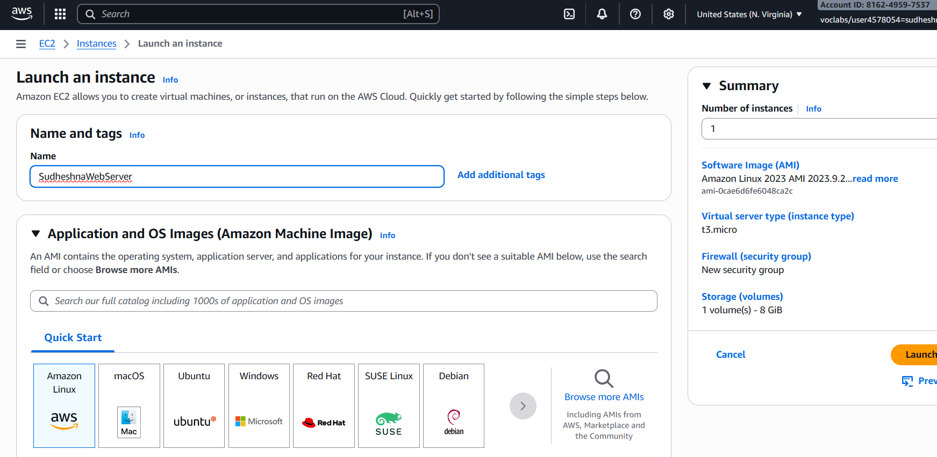

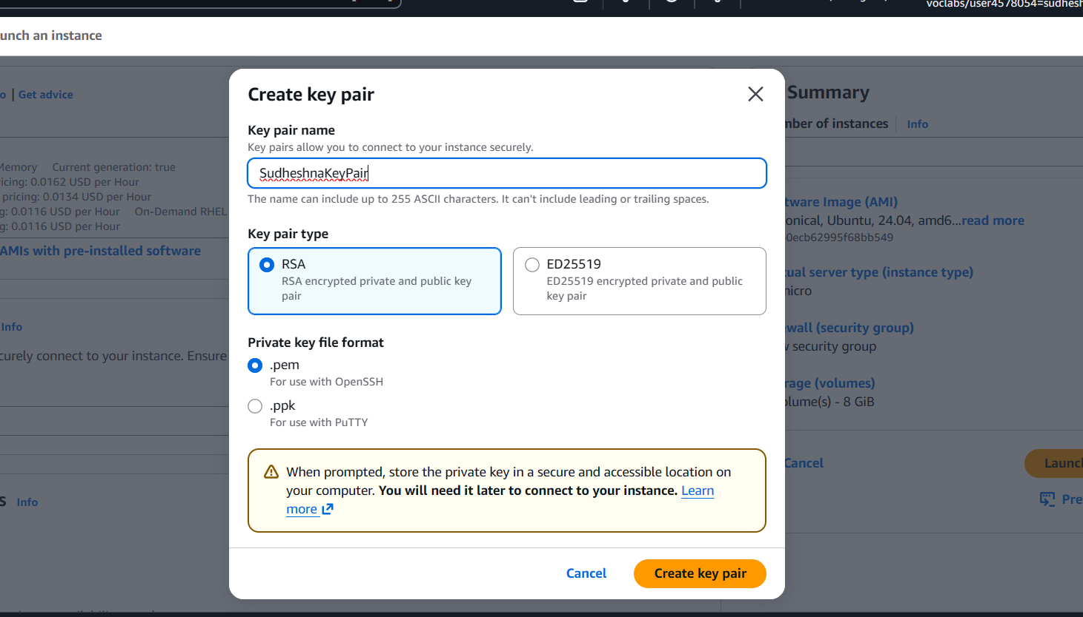

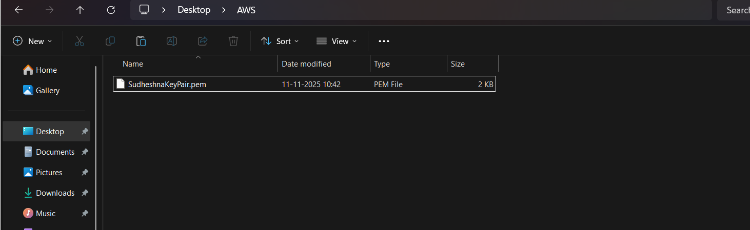

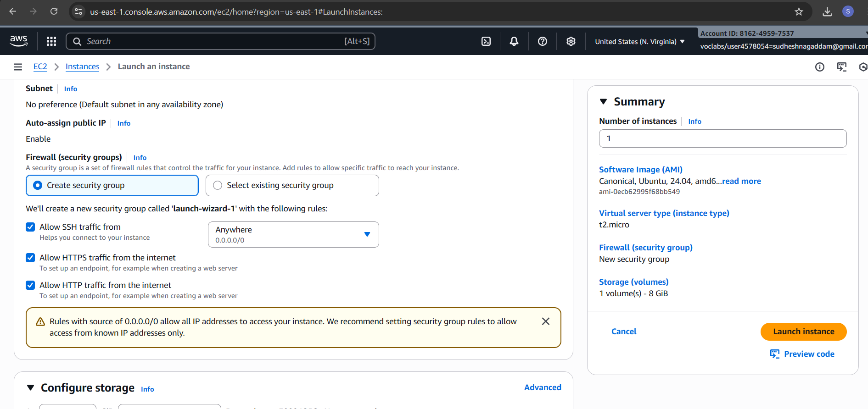

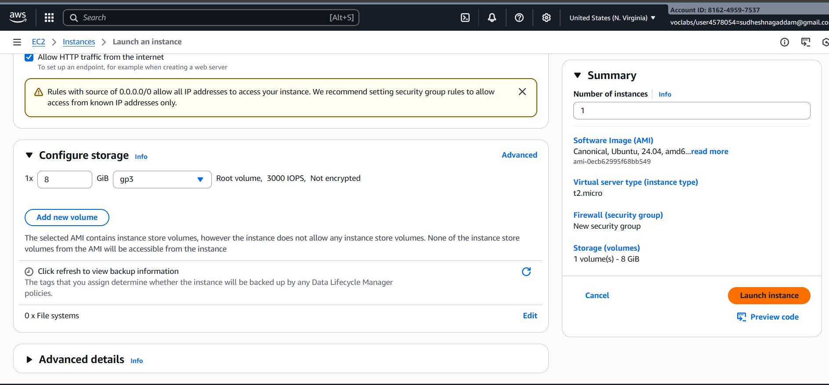

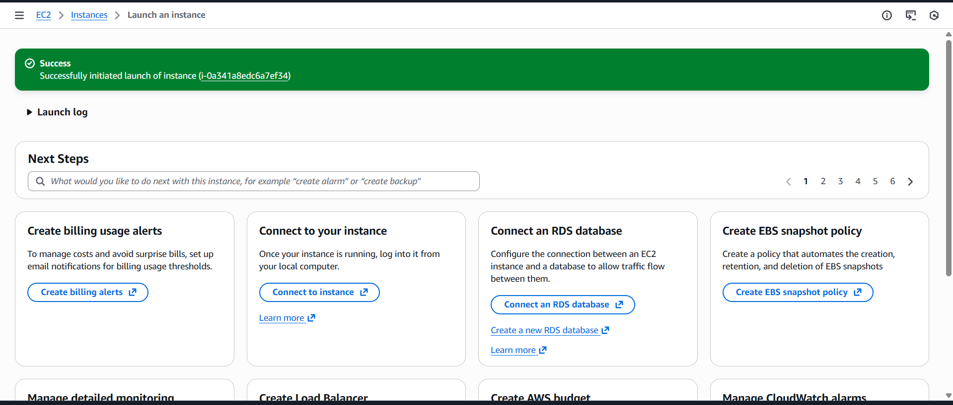

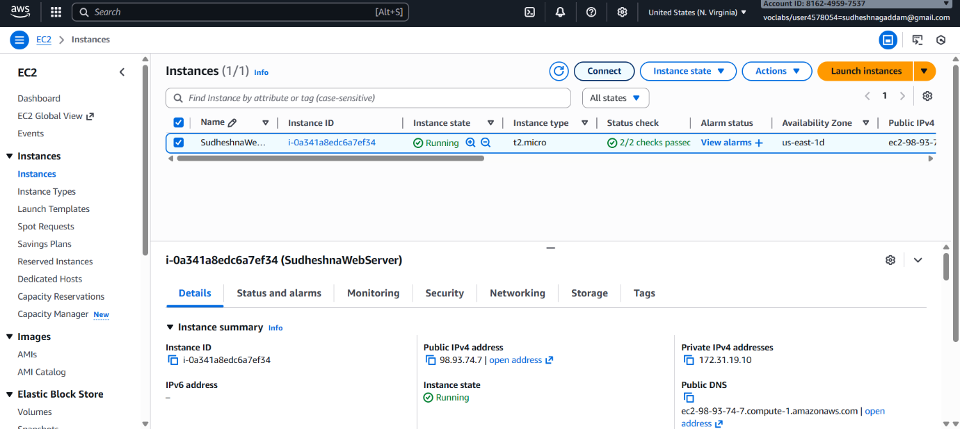

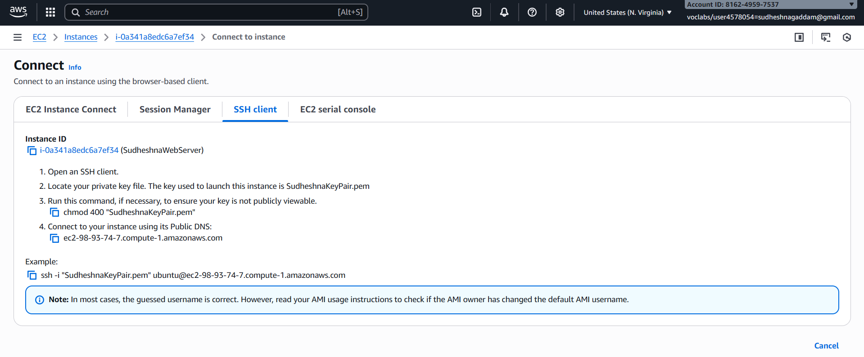

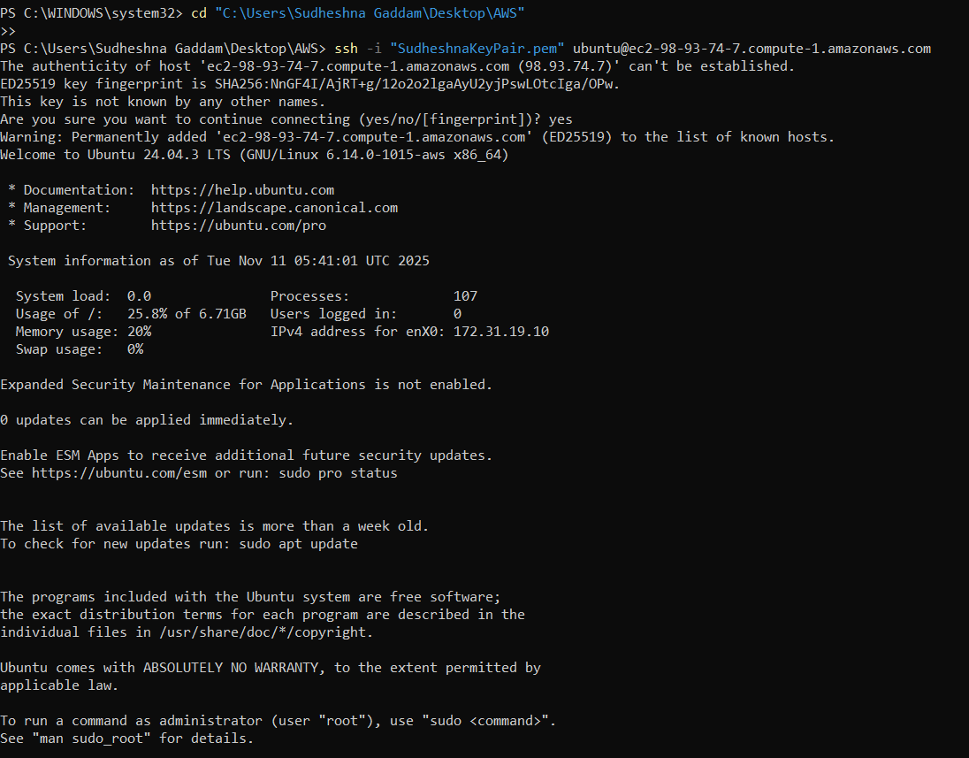

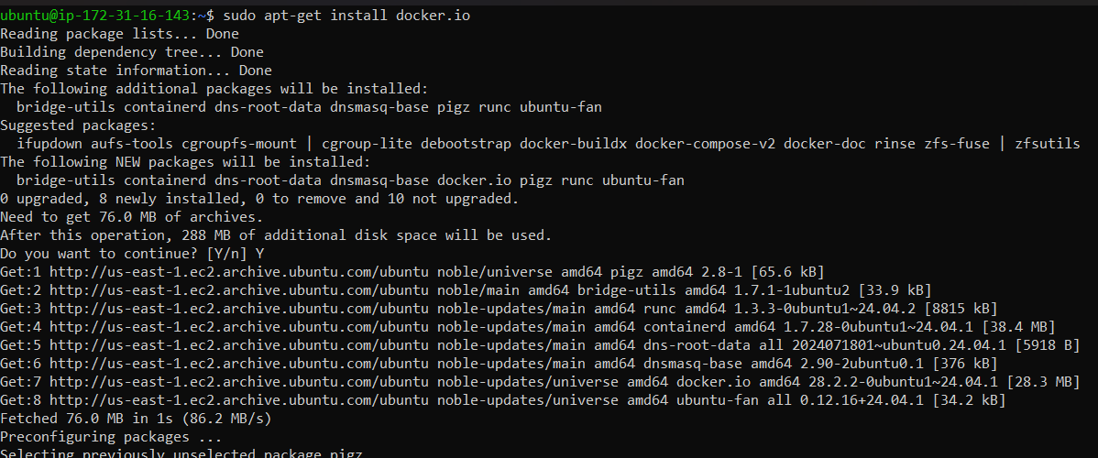

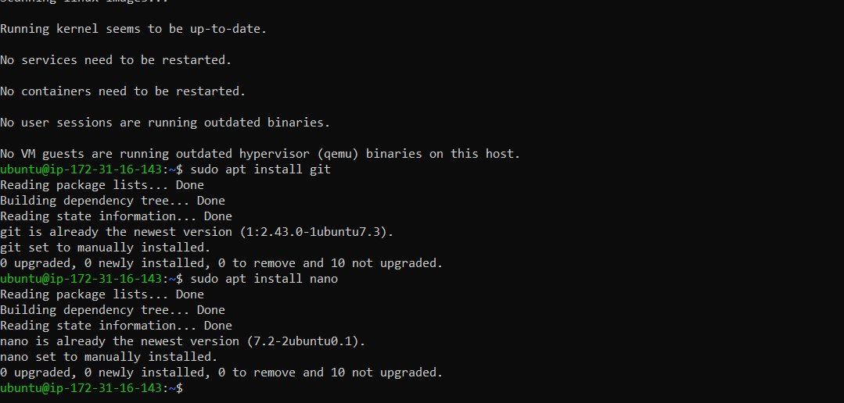

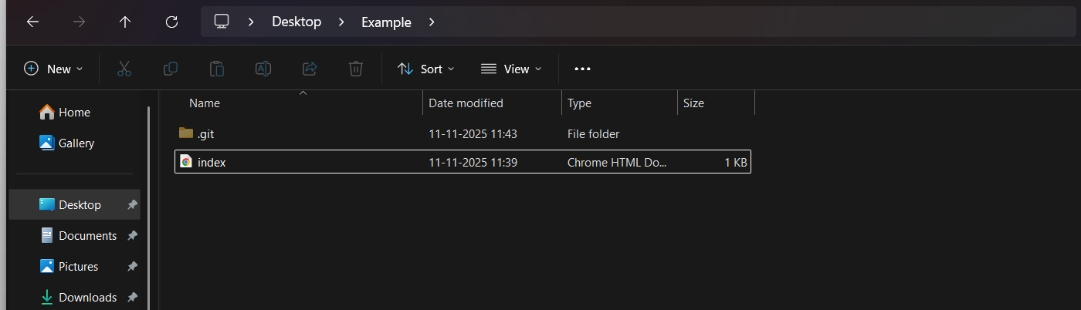

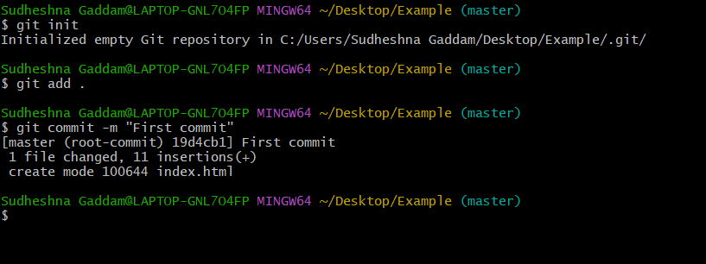

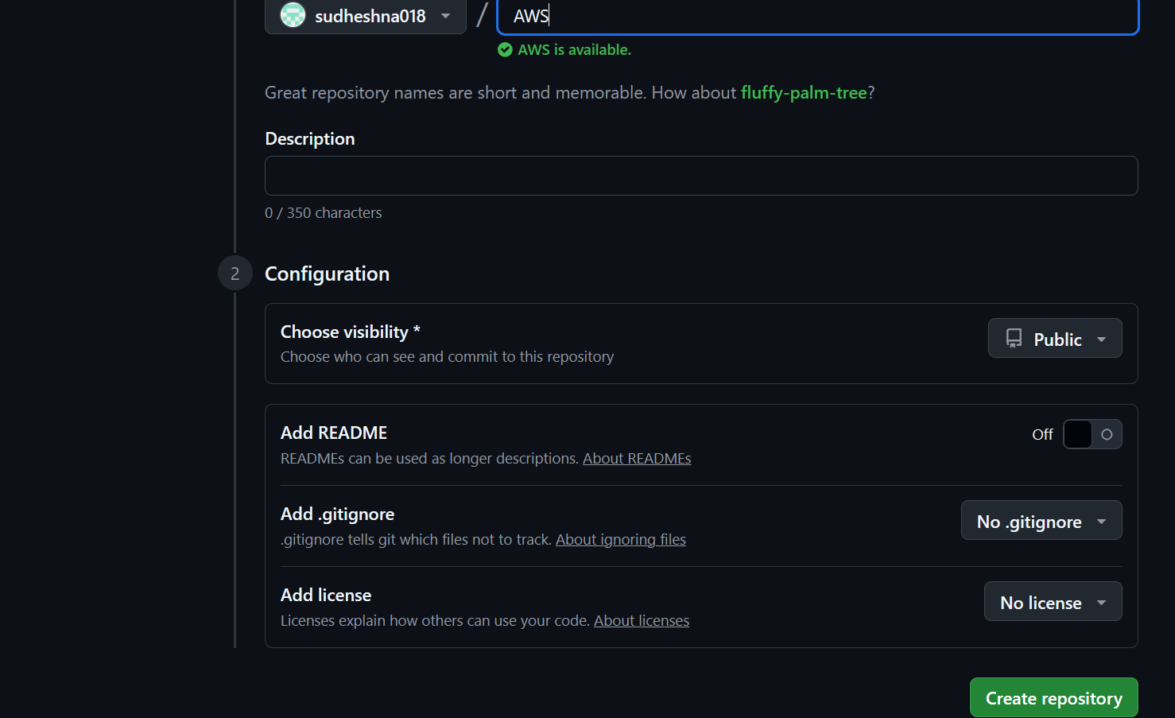

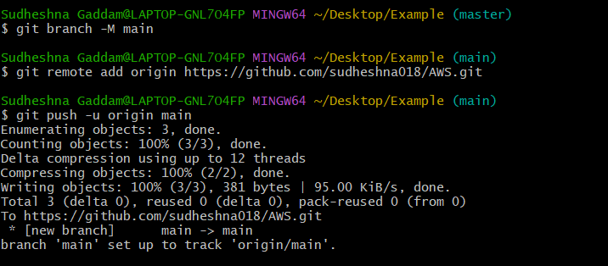

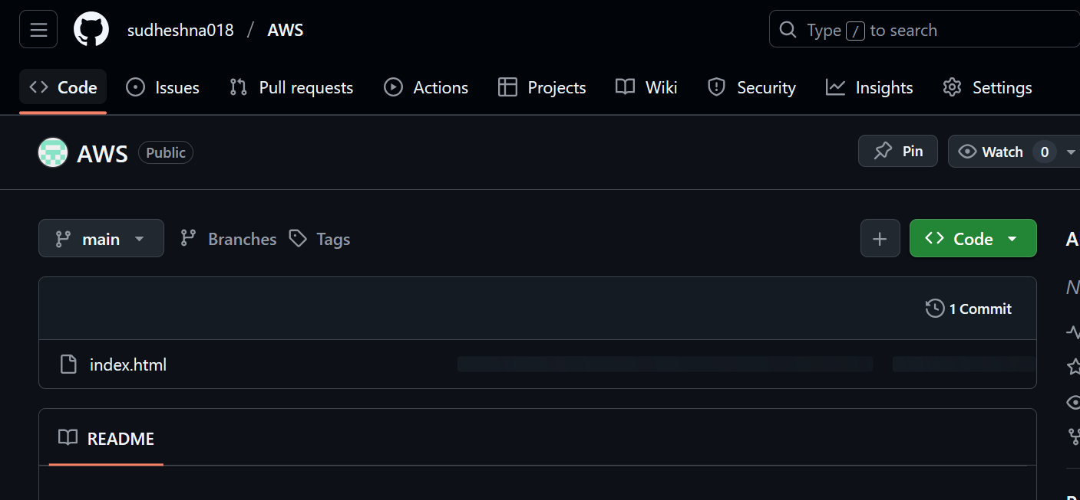

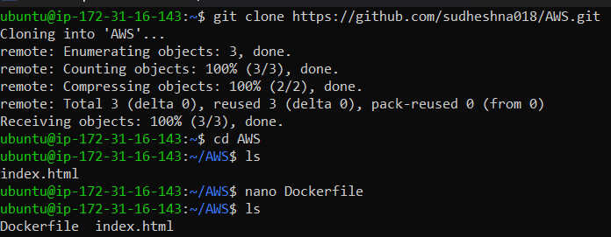

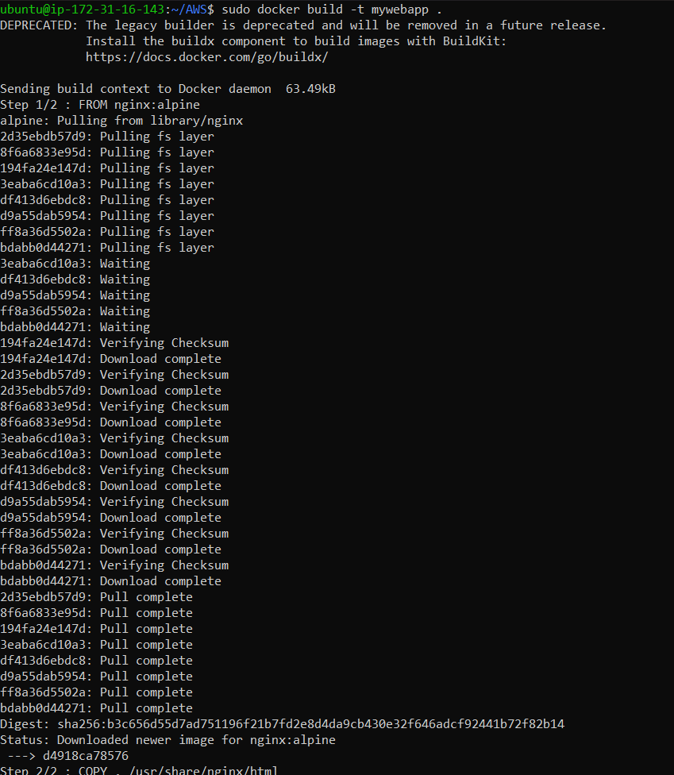

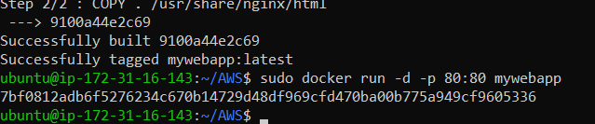

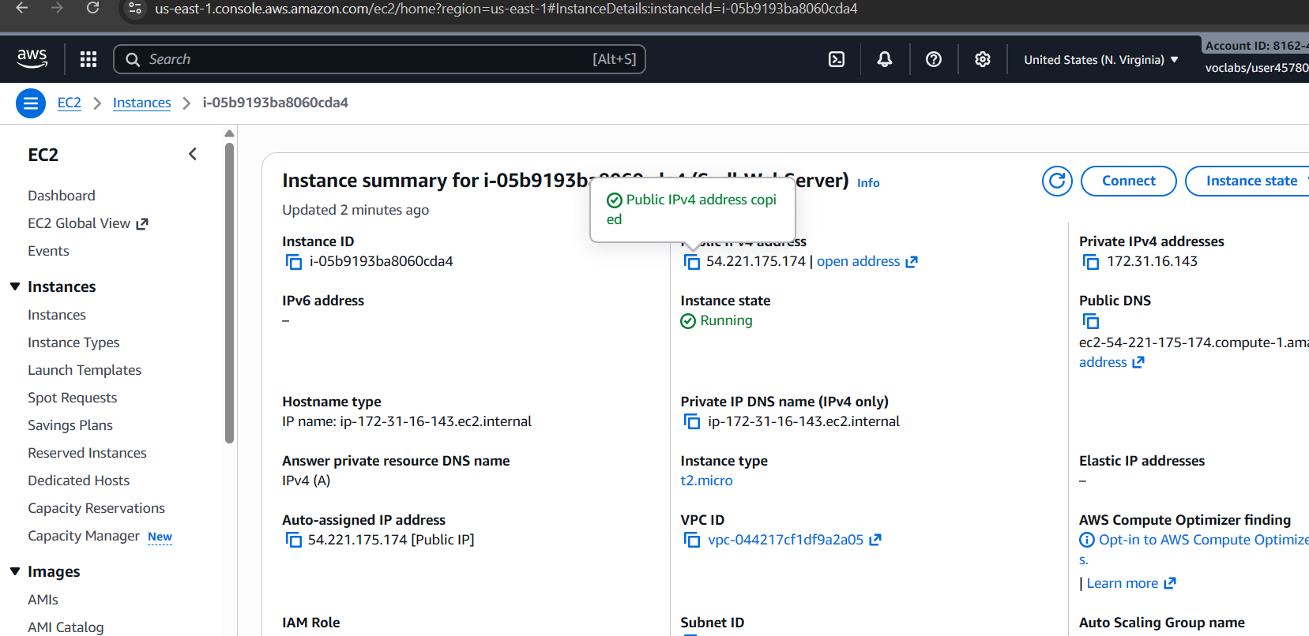

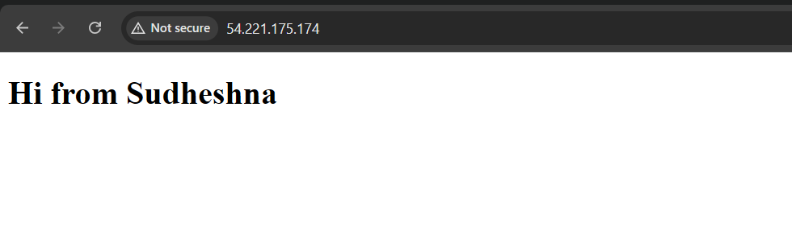



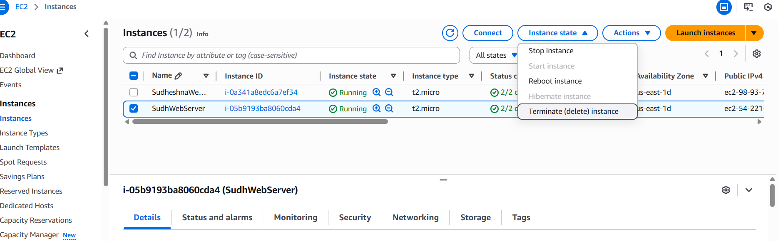

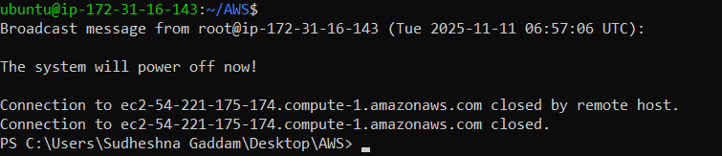

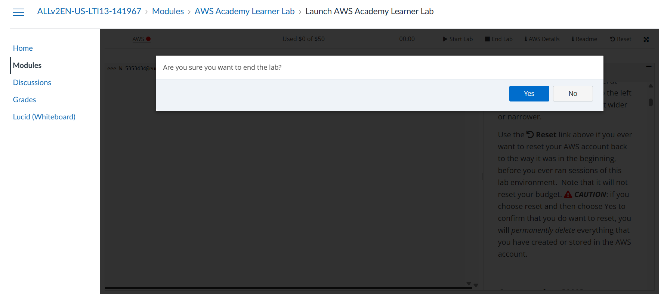

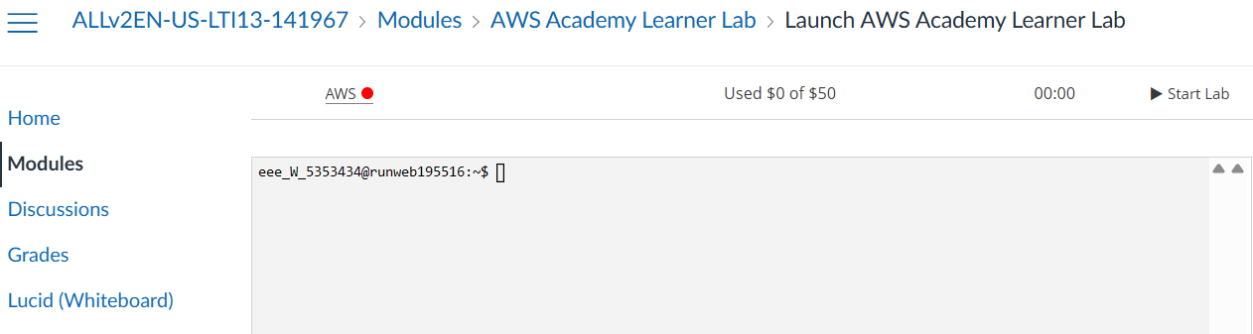

**2.Open MAVEN WEB PROJECT REPO in github and copy http link**

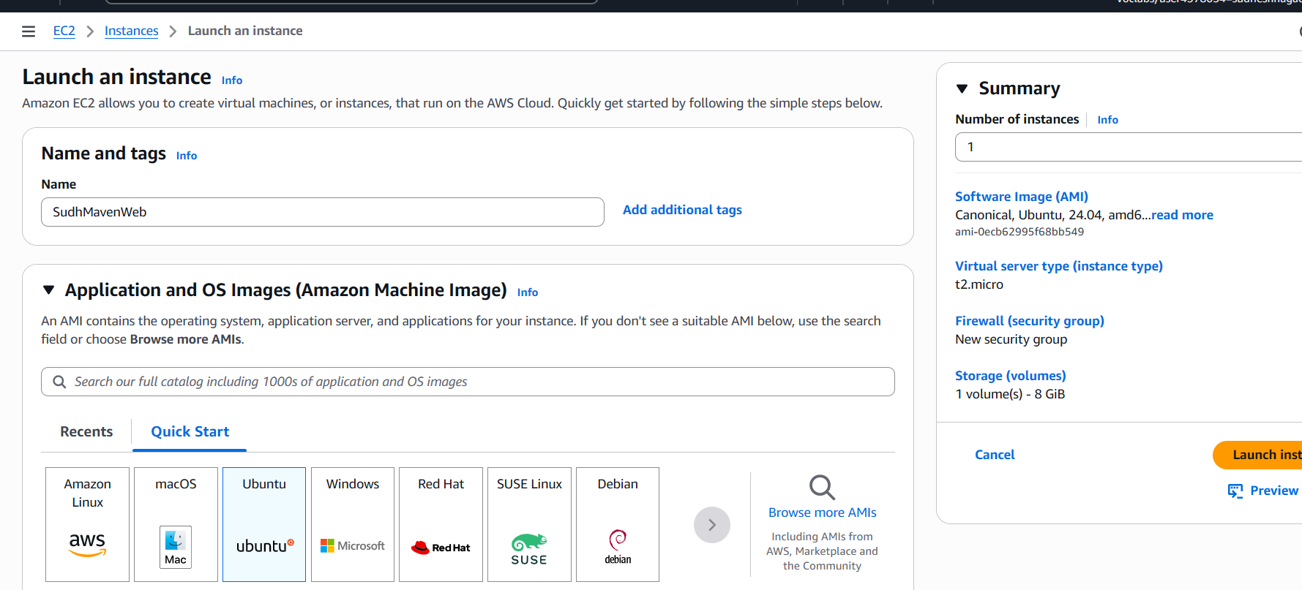

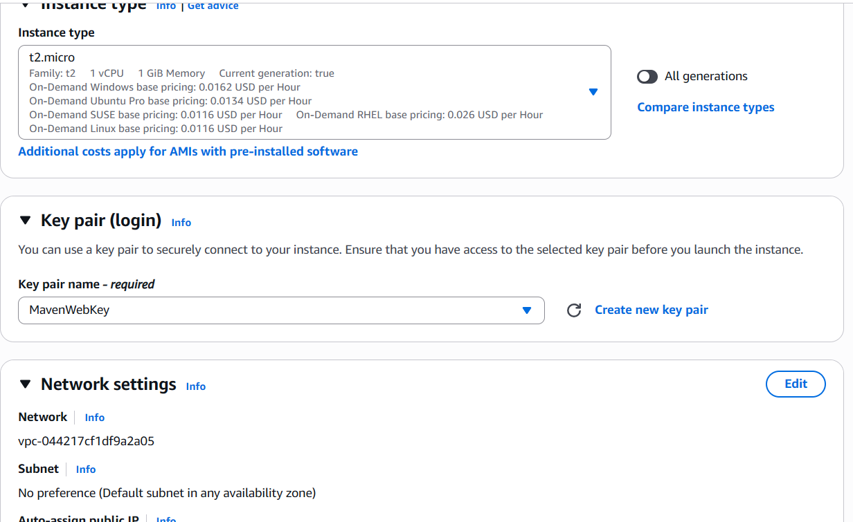

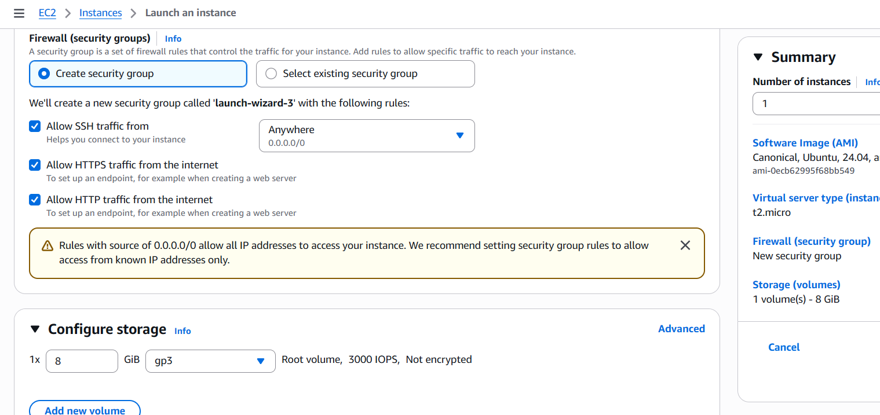

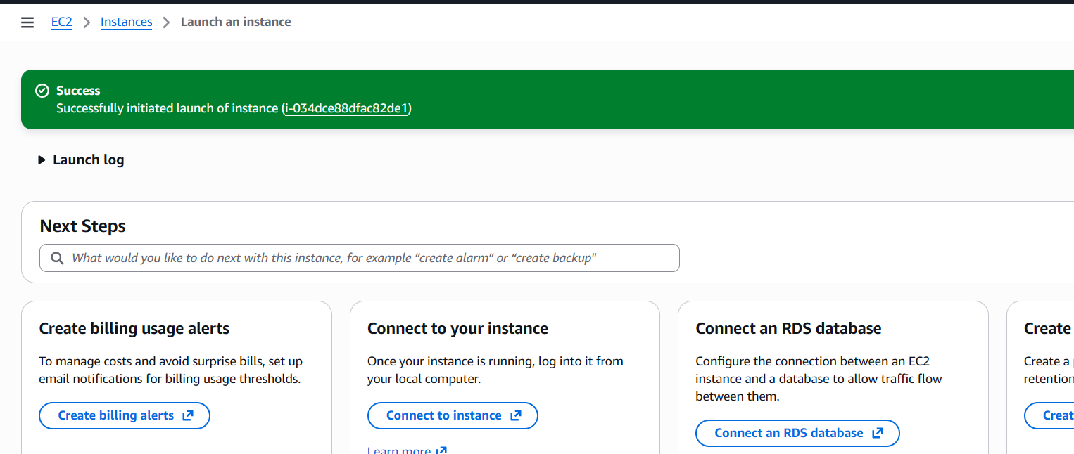

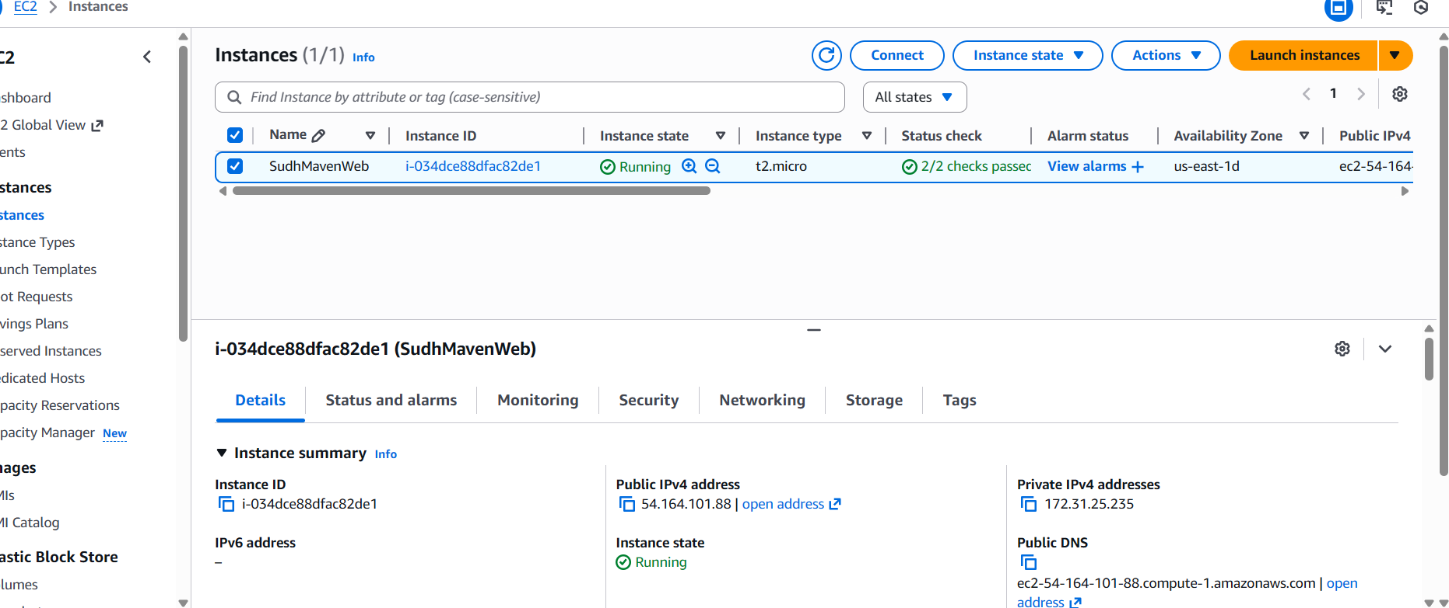

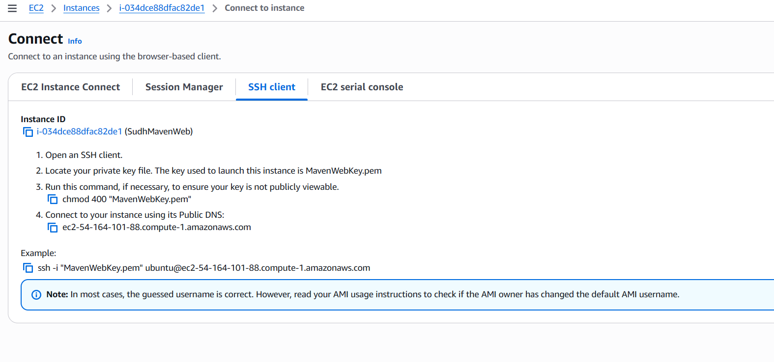

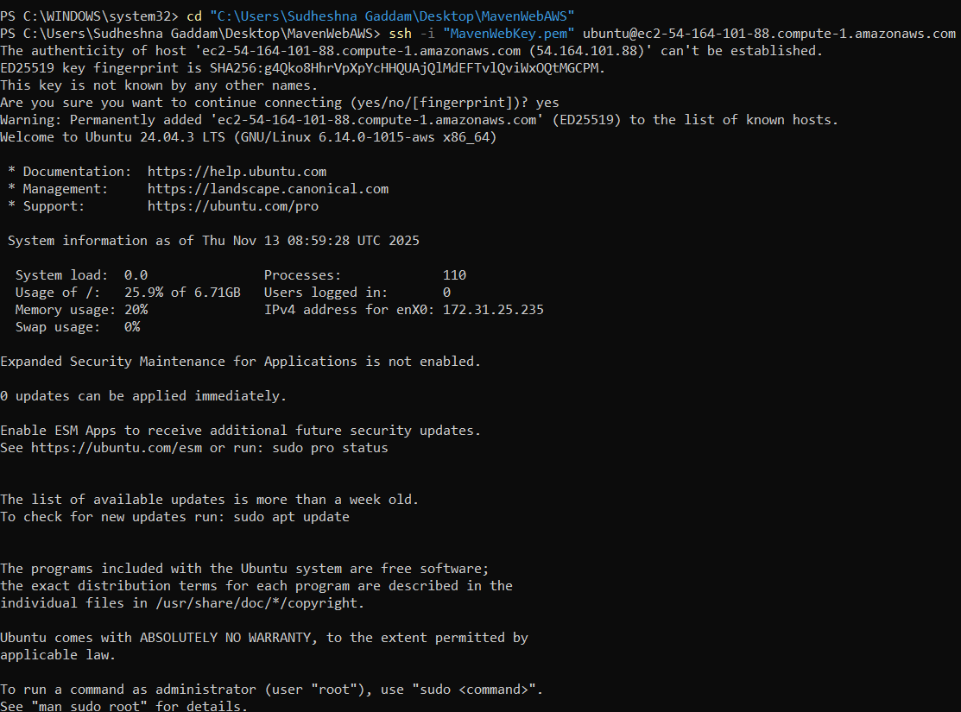

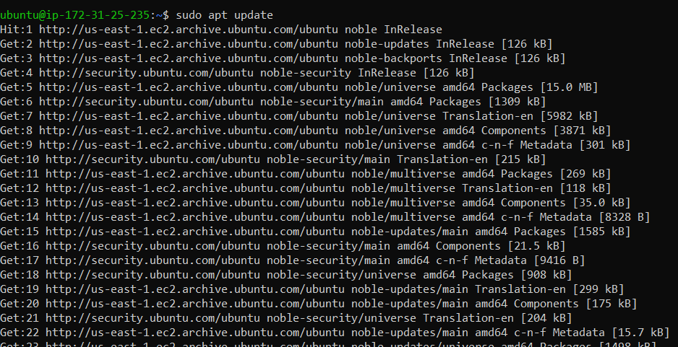

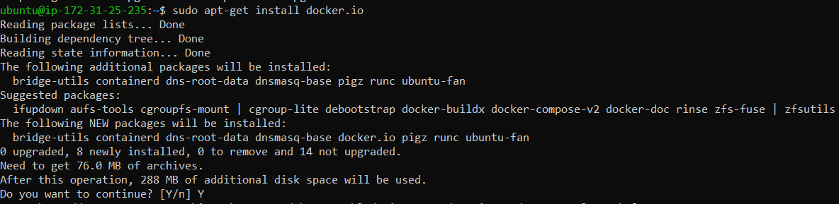

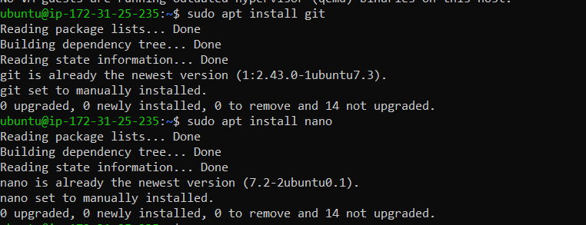

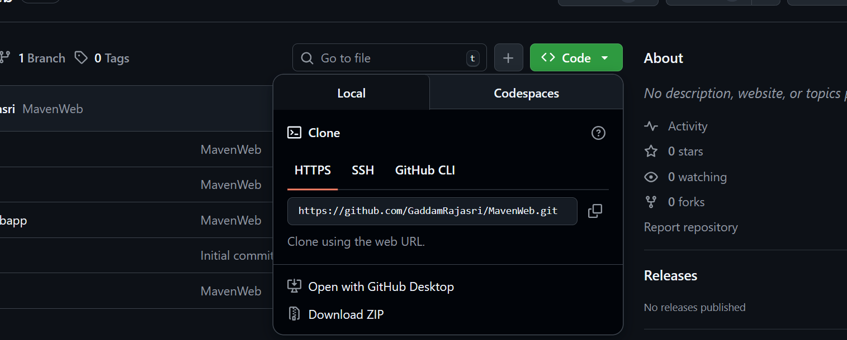

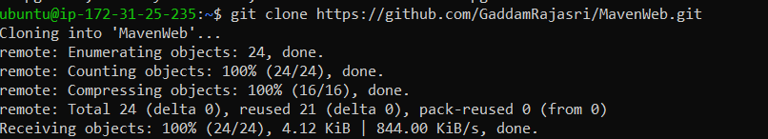

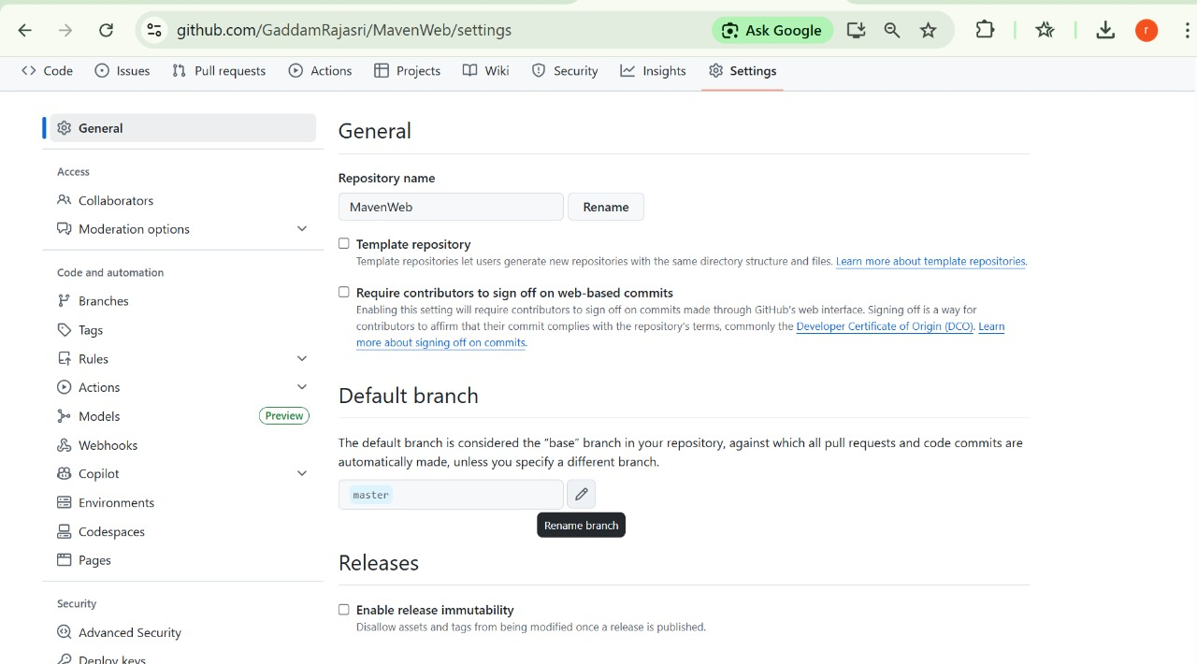

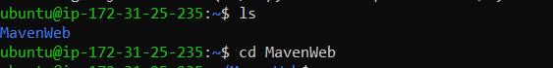



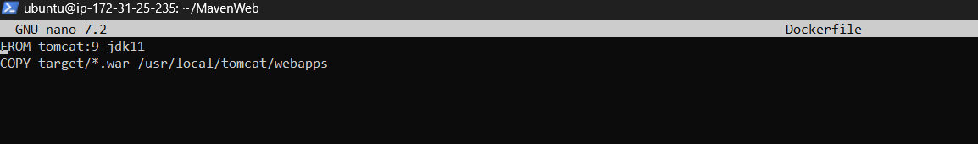

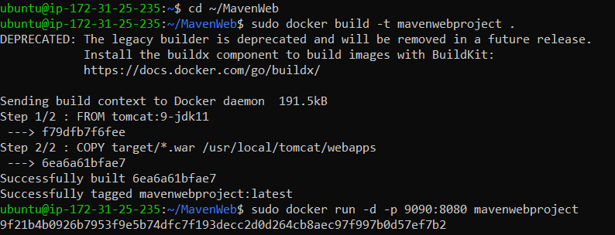

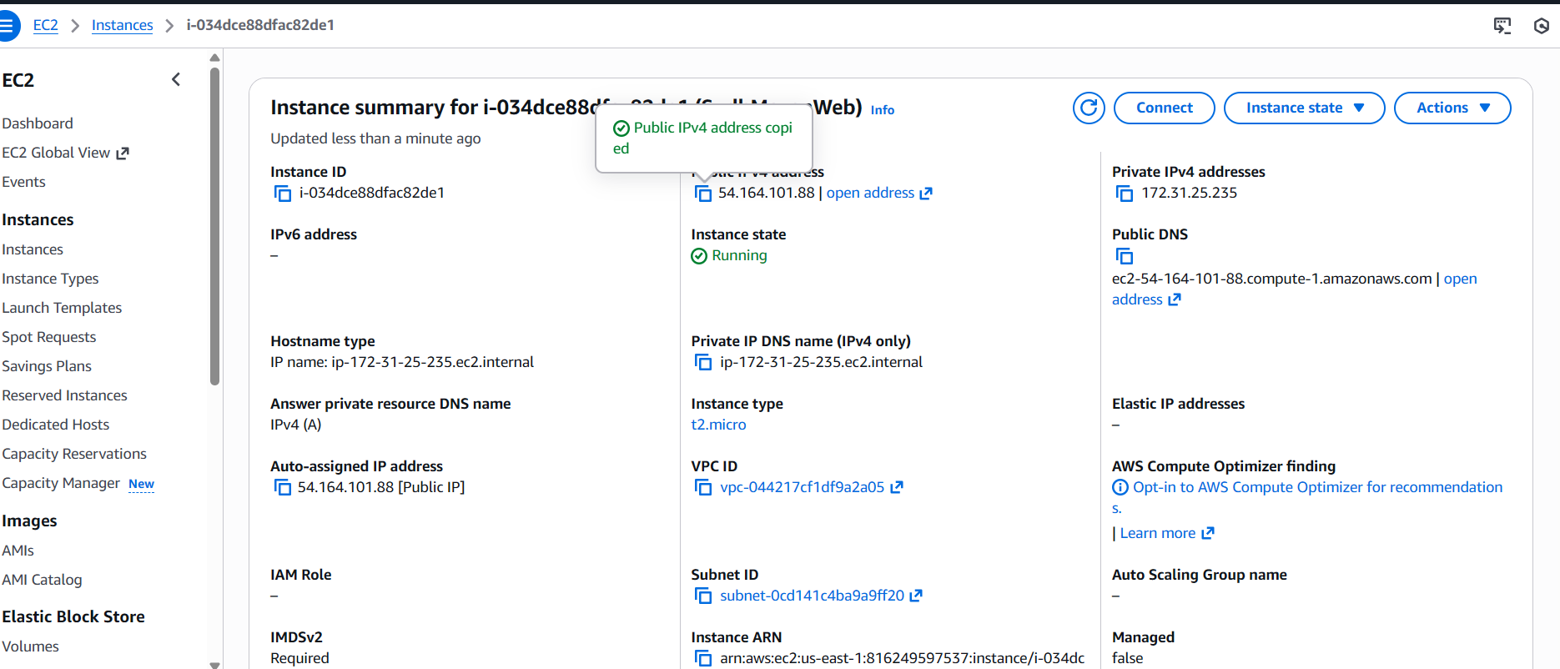

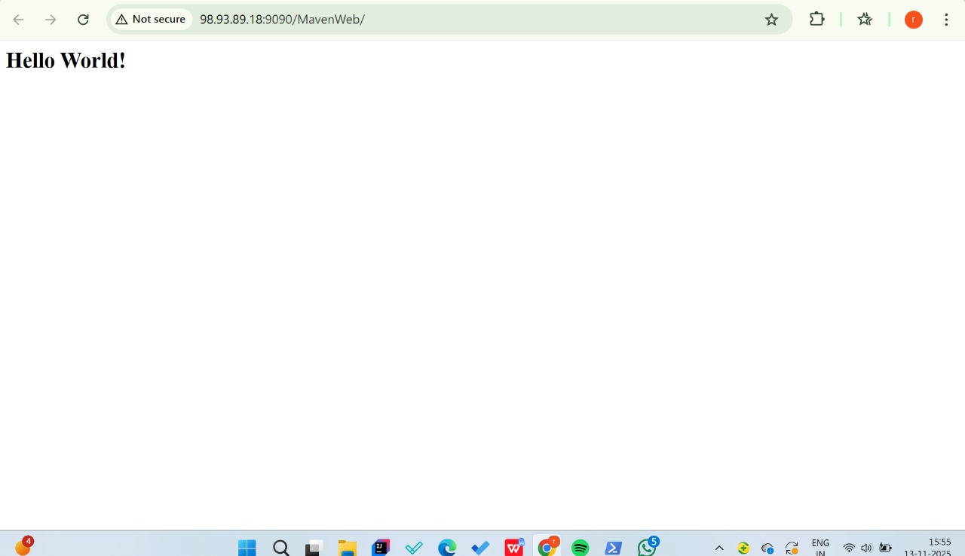

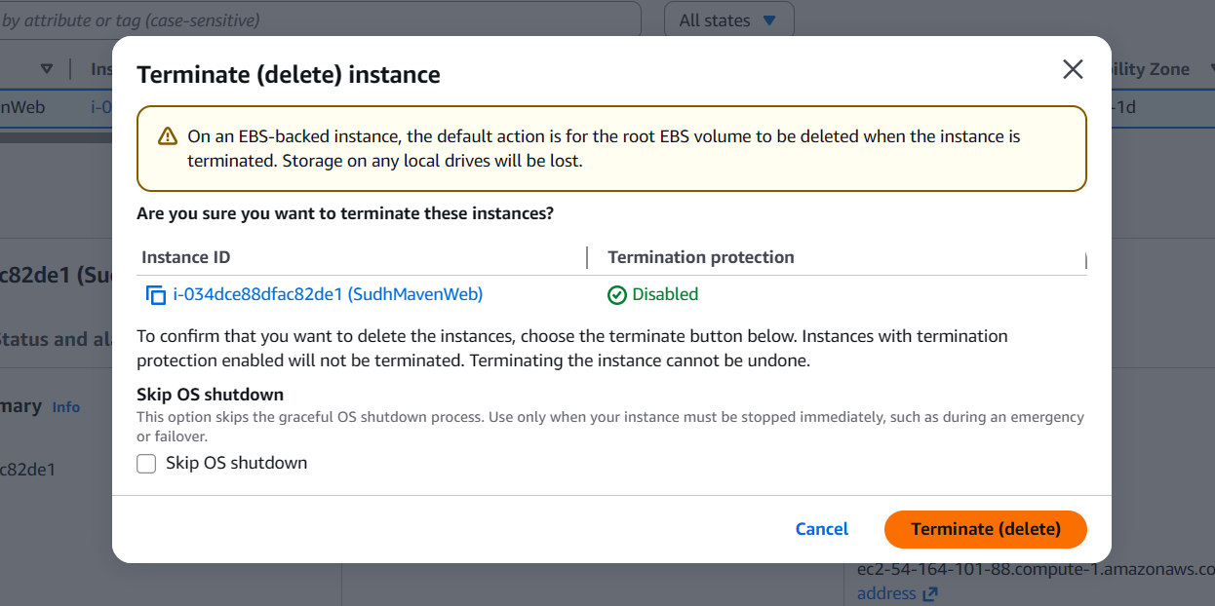

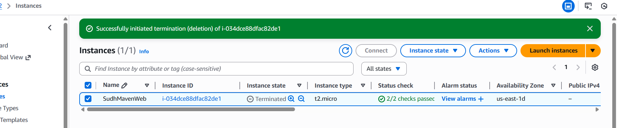

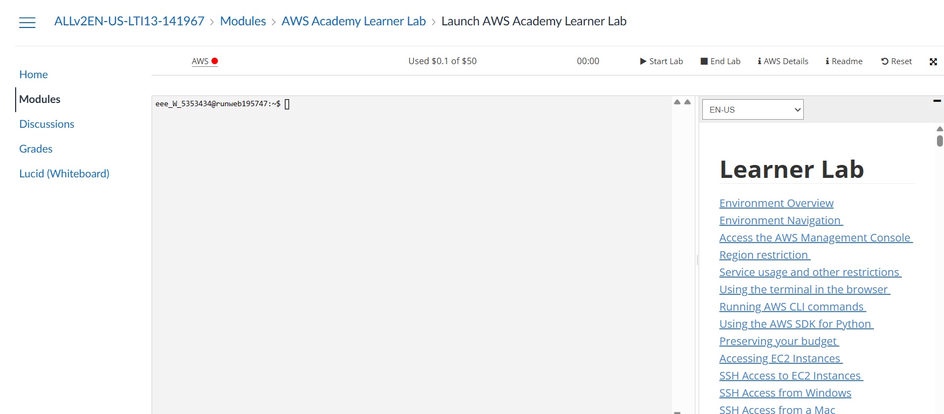

**Scenario based questions:**

1. EC2 is running but index.html not loading. What steps will you take?

Answer:

SSH into EC2

Install Apache: sudo yum install httpd -y

Start & enable service:

sudo systemctl start httpd

sudo systemctl enable httpd

Copy index.html to /var/www/html/

Allow port 80 in Security Group

2. Deployed index.html to /var/www/html but page is not loading. What will you check?

Answer:

Security Group inbound rule for HTTP (80)

Apache service running: sudo systemctl status httpd

3. Apache stops after reboot. What command enables auto-start?

Answer:

sudo systemctl enable httpd

4. Maven not installed on EC2. How to install it?

Amazon Linux 2:

sudo yum install maven -y

Ubuntu:

sudo apt install maven -y

5. Where to place .war file for Tomcat deployment and why?

Answer:

Place .war in Tomcat’s webapps directory:

/var/lib/tomcat/webapps/

Because Tomcat automatically deploys any WAR placed in this folder.

6. Tomcat deployed WAR but browser shows 404. What will you check?

Answer:

Correct URL path (MyApp.war → /MyApp/)

Tomcat running

WAR extracted properly inside webapps directory

ROOT path issues if expecting /

7. curl localhost:8080 works but browser cannot access. What is misconfigured?

Answer:

Security Group port 8080 is not open.

8. Public IP changed after reconnecting Wi-Fi. What AWS feature solves this?

Answer:

Elastic IP (static permanent IP).

9. How to auto-run deployment commands when EC2 starts?

Answer:

Use EC2 User Data script.

10. Maven needs dependency downloads but EC2 has no internet. What AWS feature fixes this?

Answer:

Use a NAT Gateway so EC2 can securely access the internet.